Assignment 05: jQuery

In this “hands-on” activity, you will discover more details about how JQuery and Bootstrap works with ASP.NET pages. This activity will take you about 3 to 6 hours, so plan accordingly!

The activity consists of the following steps:
- Study web resources.
- Create your own demo
- Submit your work to the Canvas site.

Study web resource:
Please familiarize yourself with the following topics.

- jQuery Tutorial pages
- jQuery HOME
- jQuery Intro
- jQuery Get Started
- jQuery Syntax
- jQuery Selectors
- jQuery Events

2) JQuery Tutorial Video
https://www.youtube.com/watch?v=BWXggB-T1jQ

3) Bootstrap Tutorial
https://www.w3schools.com/bootstrap/bootstrap_get_started.asp
https://www.w3schools.com/bootstrap/bootstrap_grid_basic.asp

4) Bootstrap Tutorial Video
https://www.youtube.com/watch?v=gqOEoUR5RHg

Tip: The videos are fast-paced, but remember, you can slow YouTube videos down (https://www.wikihow.com/Play-YouTube-Videos-in-Slow-Motion)!

Create your own demo
In Module 5, you saw how to use both jQuery and Bootstrap examples. With that knowledge, demonstrate your understanding of these concepts by styling your pages from assignment 04. Afterward, create a Word document showing what you did to add these styles to your website.

1) Create a new ASP.NET website project called “Assignment05.”
2) Add the pages/code from assignment04 to your current site.
2) Add jQuery and Bootstrap to improve your website.
3) Create a tutorial document showing how you styled your website with jQuery and Bootstrap.

NOTES:
1) Make sure you format it like a college paper instead of the text message. Things like having your name, date, class, and citations are always expected of a college student!
Please review this website for some examples: http://jerz.setonhill.edu/writing/academic1/mla-style-papers/ (Links to an external site.)
Note: Not putting your name, course, and date at the top of the document you will cost you 25% of your grade.
2) Make your paper better by considering these tips:
https://www.wikihow.com/Write-a-Tutorial

Submit your work to the Canvas site.
After you complete you your Assignment website, place the resulting files and folders into another folder, both the document and the Visual Studio Solution/Project sub-folder, and turn everything into a single zip file. Then post the zip file on the Canvas website, in the appropriate module under Assignments.
(http://www.wikihow.com/Zip-Files-Together)

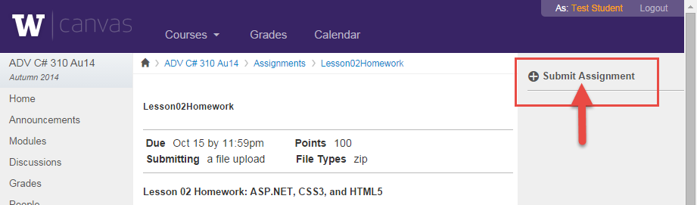

You’re done!!!

